- App: setup -> quick find search -> apps -> create app -> new -> nation visa
- Object – applicant
- Object is platform independent. Setup -> quick find search –> objects -> creating obj -> new
- AutoNumber on, and other 4 features tick, allow searches tick
- Create object -> applicant -> custom field and relationships -> then make new fields
- First name, last name, dob, gender -> fields

Today’s notes
Formula field: is a read only field which derives its value from another field.

User story – 1
Create a formula field, name – “age”
Which calculates age from dob field.

- First click on setup -> search “applicant” in apps.
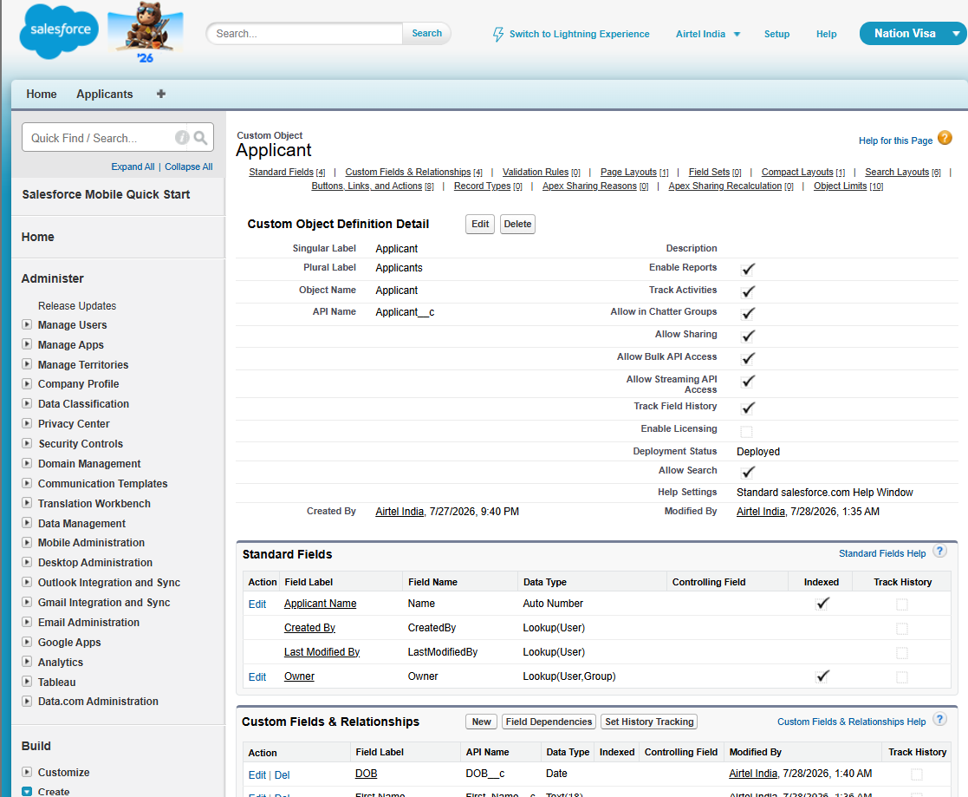

- Click on new –
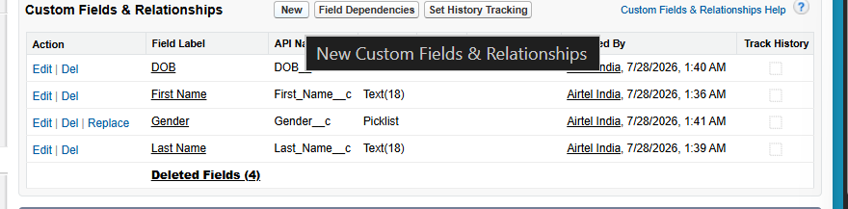
- Formula field select.
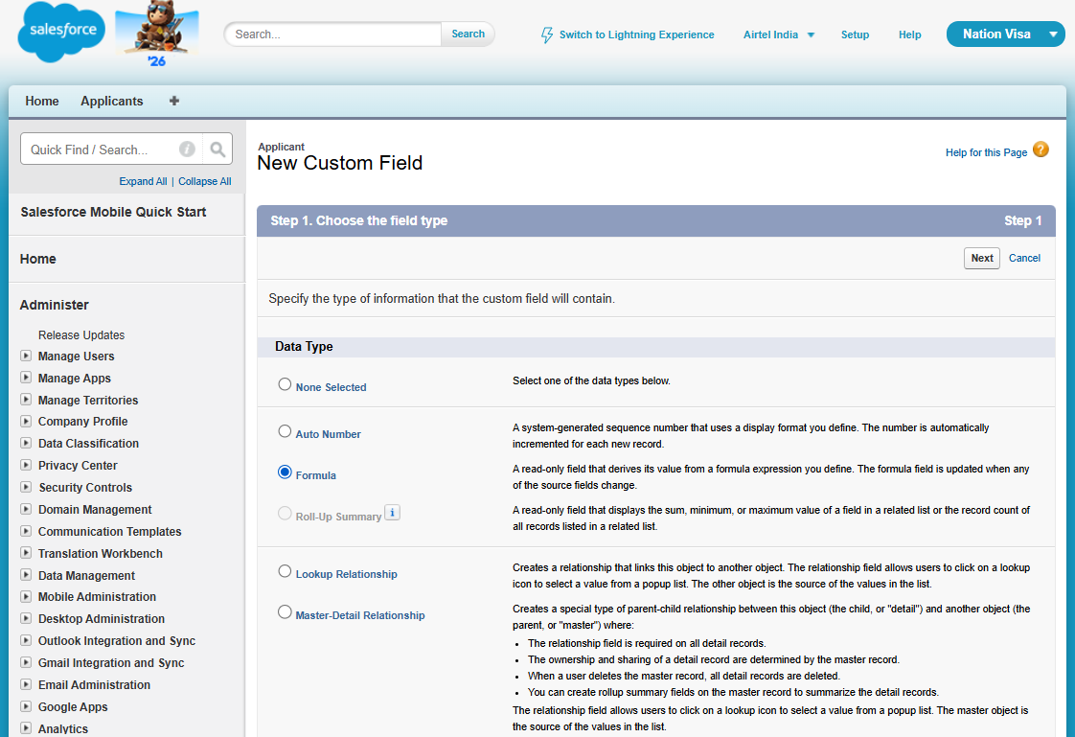

- Select formula and then return type.
- Fill form
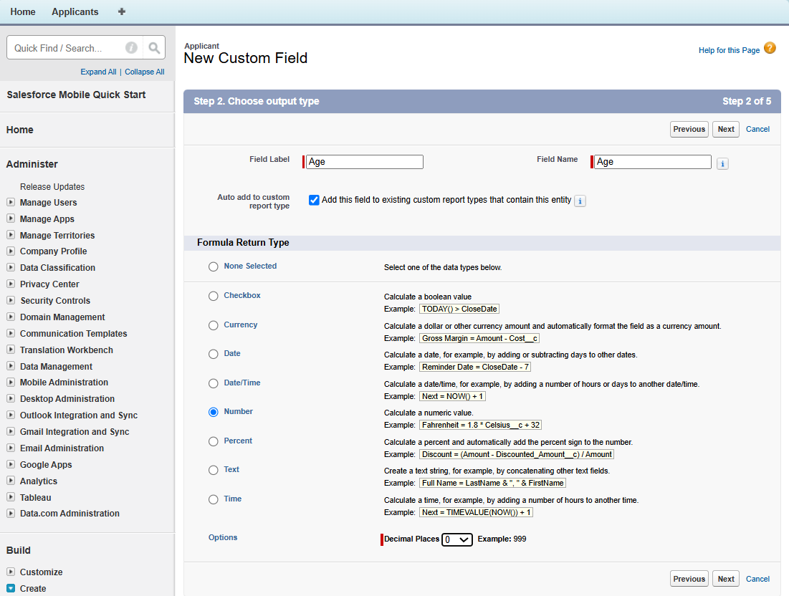

- Now choose advanced formula
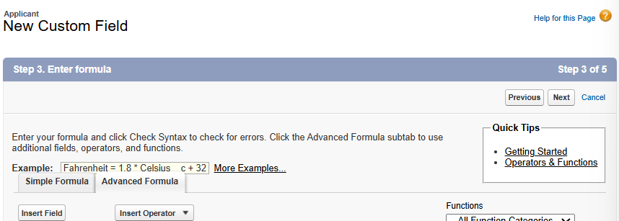

- Search today in function. And double click on it and it appears in age(number) = formula box
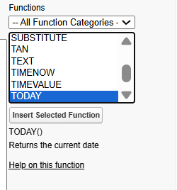

- Insert the dob from applicant object.
Click on insert field.
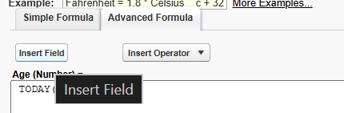

Then choose dob. From applicant object. And it shows its api name and insert it.

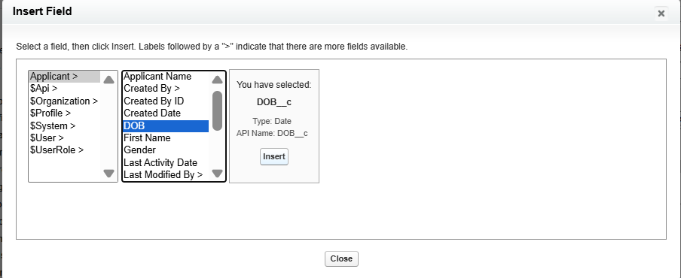

Write formula
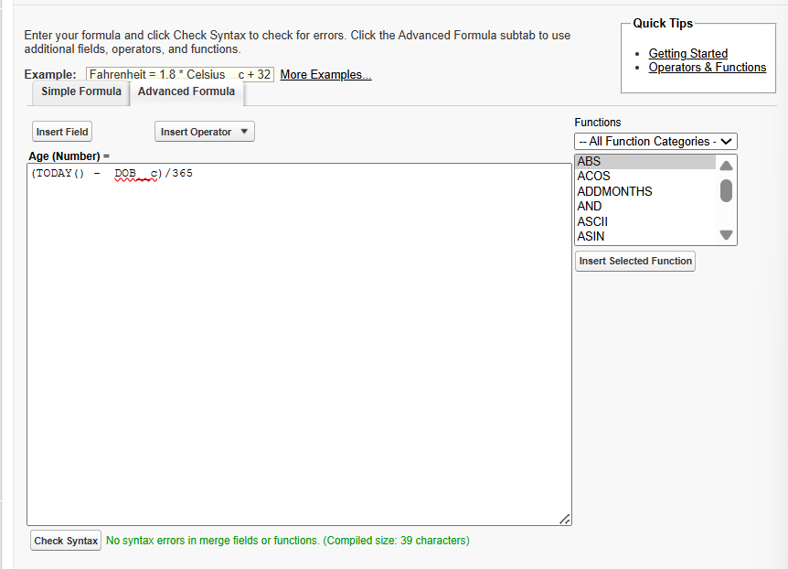

Check syntax after writing formula-

- Create a new applicant from applicant tab. And check new field is added that is formula filed(age).
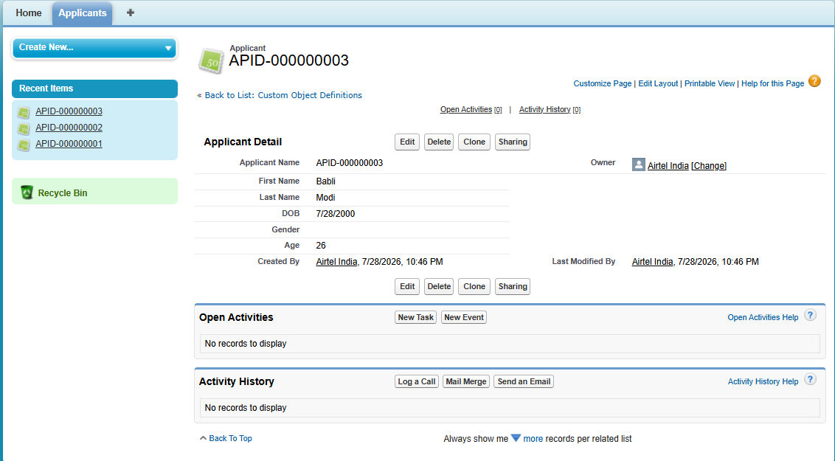

Its locked you cant change it, it is in read-only mode.

If you change dob, it changes age.
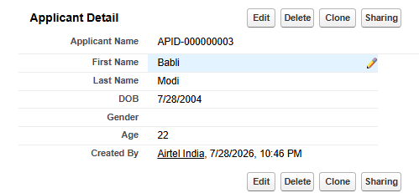

User story – 2
Create a formula field, “eligible” for voting returns a checkbox.
If age >= 18, return “tick”
Else, return unchecked.

- Objects -. Create -> applicant -> field -> new filed -> formula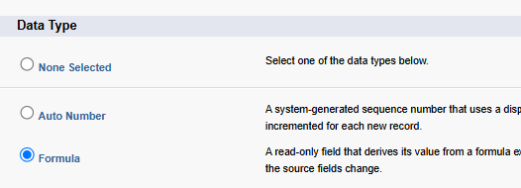
- Check box choose.
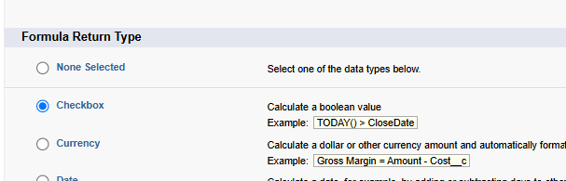

- Choose if
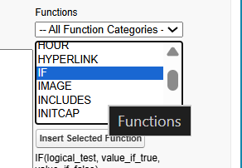

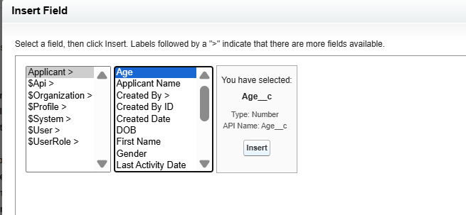

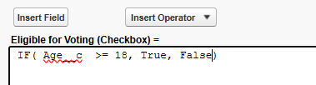

Visible to all tick it.

- Checked the eligibility
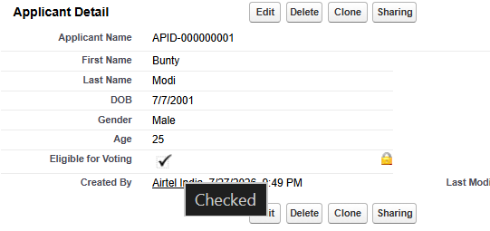

- Unit testing – checking the single test case for our work if its up to the mark.
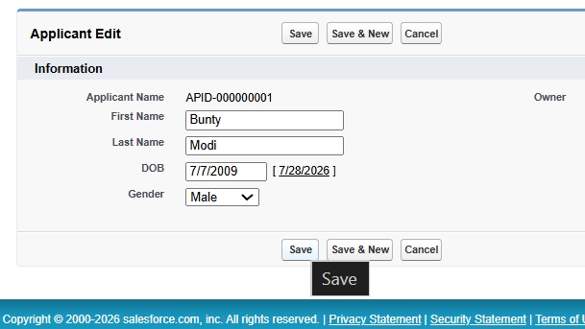

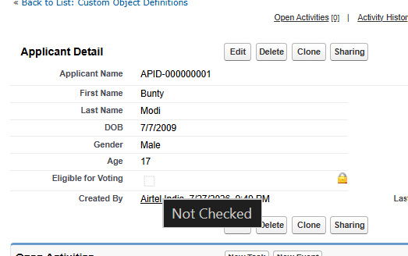

User Story – 3
Create a formula field “applicant status” which returns text according to the age.
If age >= 18, print = “major”
Else, print = “minor”
- Very easy, did it on my own.
- Formula field, text return.
- If (condition, then for true – “major”, false – “minor”)

User Story – 4
Create a formula field, “eligibility”. According to the age, show eligibility logo.
If age >= 18, yes – logo
Else, no – logo

1. Click on ‘+’ sign -
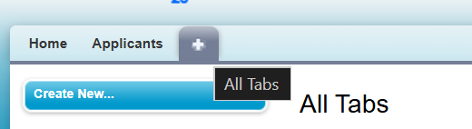
2. Scroll and search for document and click on it
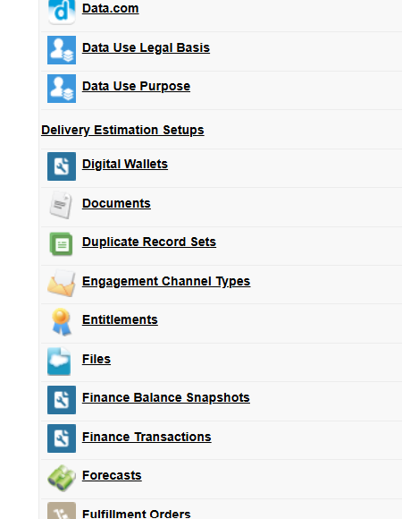

3. Click on “new”-
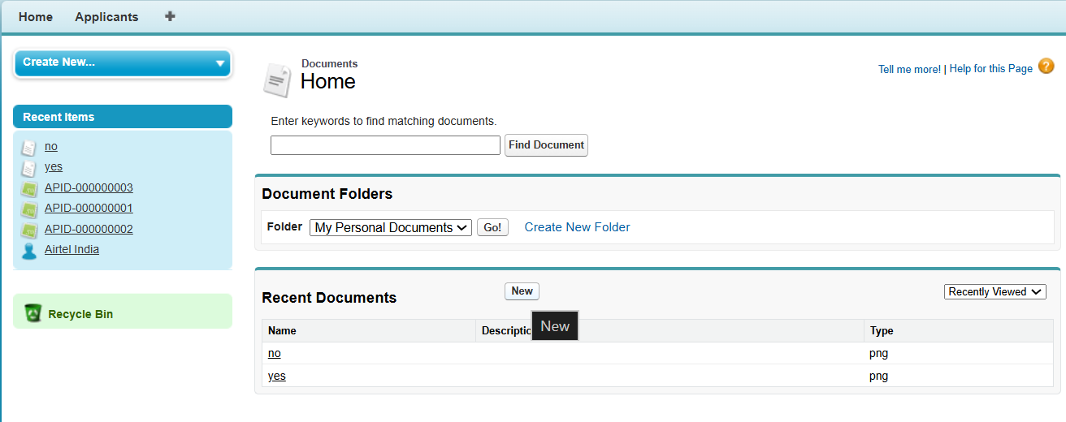

- click on tick option for “externally available image”-
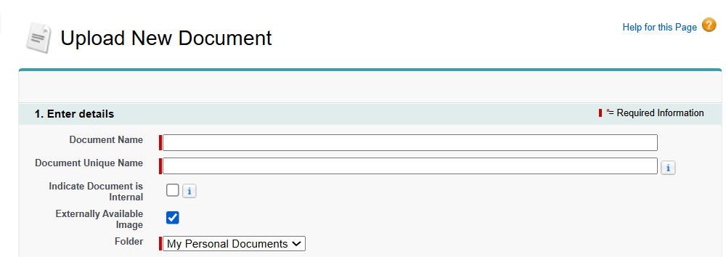
- Choose file and save it. Then open image and copy its link-
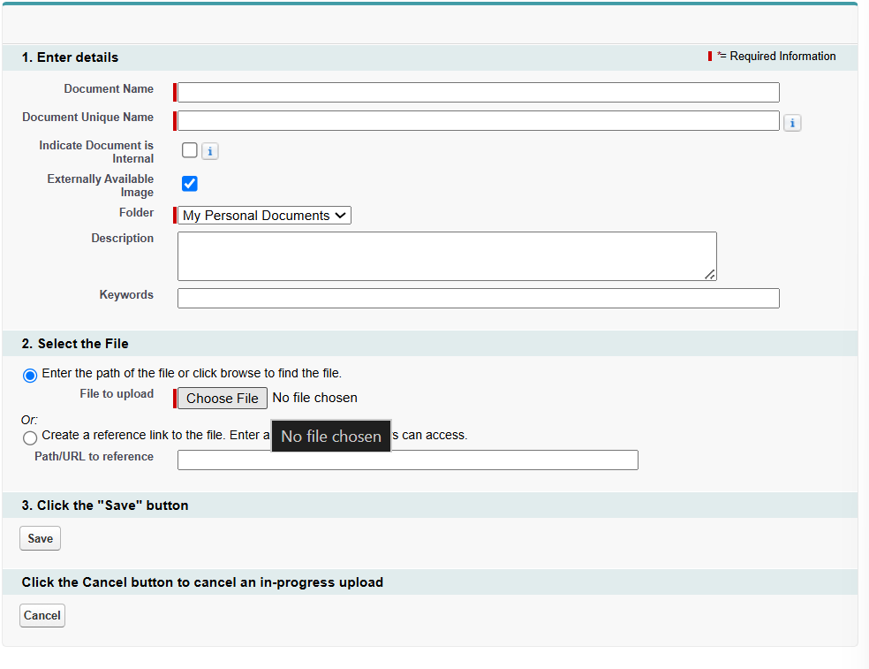

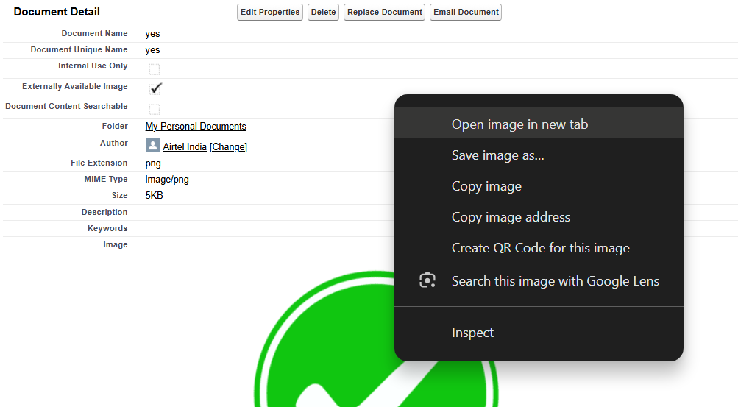

Copy link of both of them-
Yes logo link - https://orgfarm-b79ae2a0d4-dev-ed.develop.my.salesforce.com/servlet/servlet.ImageServer?id=015bm00000CR6qP&oid=00Dbm00000rt24H&lastMod=1785425506000
No logo link- https://orgfarm-b79ae2a0d4-dev-ed.develop.my.salesforce.com/servlet/servlet.ImageServer?id=015bm00000CR9BZ&oid=00Dbm00000rt24H&lastMod=1785426757000

- Result –
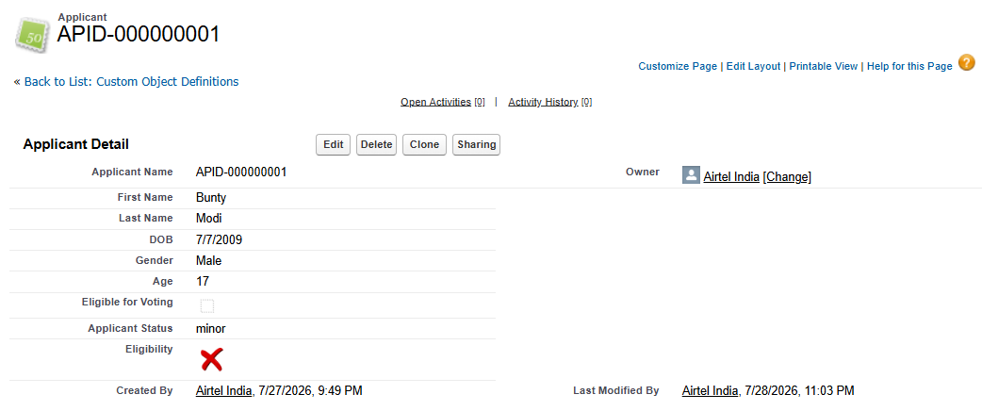

User Story – 5
Create a eligibility for gender. Female, Male and transgender- “gender logo”
Male- male-logo
Female – female-logo
Others – transgender-logo (not allowed)

- Create a formula field-
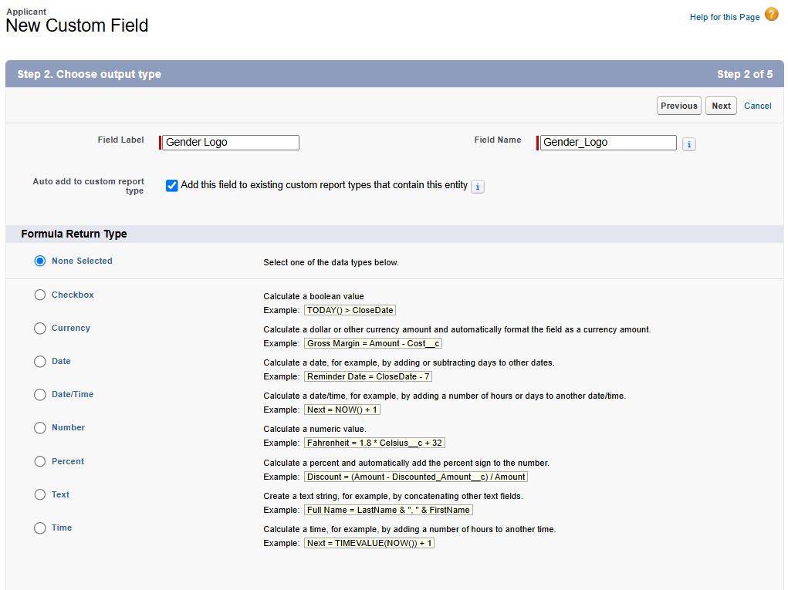

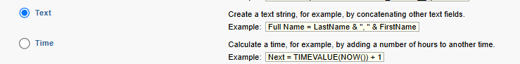

Return type sleect text.

- First create link for all 3 images-
Male : https://orgfarm-b79ae2a0d4-dev-ed.develop.my.salesforce.com/servlet/servlet.ImageServer?id=015bm00000CRGkv&oid=00Dbm00000rt24H&lastMod=1785430061000

Female: https://orgfarm-b79ae2a0d4-dev-ed.develop.my.salesforce.com/servlet/servlet.ImageServer?id=015bm00000CRHFZ&oid=00Dbm00000rt24H&lastMod=1785430255000

Transgender: https://orgfarm-b79ae2a0d4-dev-ed.develop.my.salesforce.com/servlet/servlet.ImageServer?id=015bm00000CRHIn&oid=00Dbm00000rt24H&lastMod=1785430302000

- Formula –
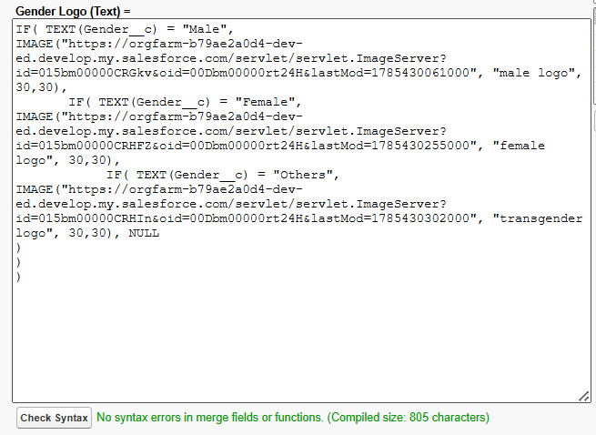
IF( TEXT(Gender__c) = "Male",
IMAGE("https://orgfarm-b79ae2a0d4-dev-ed.develop.my.salesforce.com/servlet/servlet.ImageServer?id=015bm00000CRGkv&oid=00Dbm00000rt24H&lastMod=1785430061000", "male logo", 30,30),
IF( TEXT(Gender__c) = "Female",
IMAGE("https://orgfarm-b79ae2a0d4-dev-ed.develop.my.salesforce.com/servlet/servlet.ImageServer?id=015bm00000CRHFZ&oid=00Dbm00000rt24H&lastMod=1785430255000", "female logo", 30,30),
IF( TEXT(Gender__c) = "Others",
IMAGE("https://orgfarm-b79ae2a0d4-dev-ed.develop.my.salesforce.com/servlet/servlet.ImageServer?id=015bm00000CRHIn&oid=00Dbm00000rt24H&lastMod=1785430302000", "transgender logo", 30,30), NULL)))

- TICK the visible box.
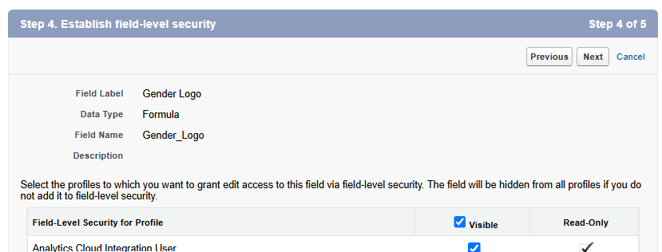

- Result-
